**SYSTEM DEVELOPMENT PROJECT**

( ONLINE HOME SERVICE WEB-APPLICATION)

SUBMITTED BY

|  |  |
| --- | --- |
| ROLL NO | NAME |
| 3202 | Darshna Limbani |
| 3268 | Hardi Desai |
| 3271 | Pratixa Bhuva |

**Group ID: - 85**

**Name of Company:** DCODE Soft

**Date of submission:** 2022



Contents

1. Introduction 3

1.1 ORGANIZATION PROFILE 3

1.2 SYSTEM DETAILS 3

1.2.1 EXISTING SYSTEM 3

1.2.2 PROPOSED SYSTEM 4

1.3 SCOPE OF SYSTEM 5

1.4 OBJECTIVES 5

2. PROPOSED SYSTEM REQUIREMENT GATHERING 6

2.1 STAKEHOLDERS OF SYSTEM 6

2.2 REQUIREMENT GATHERING TECHNIQUE USED 7

2.3 Consolidated List of Requirements 7

2.4 Project Definition 8

3. SYSTEM MANAGEMENT AND PLANNING 9

3.1 Feasibility study 9

3.1.1 Technical study 9

3.1.2 Economical Study 9

3.1.3 Operational Study 10

3.2 Hardware/Software Requirement 10

3.3 System Planning 11

3.3.1 Work breakdown Structure 11

3.1.4 Gantt Chart 12

3.4 Process Model 13

Ch 4 System Analysis and planning 14

4.1UML (Unified Modeling Language) 14

4.1.1 Use Case Diagrams 14

4.1.2 Activity Diagram 15

4.1.3 Sequence Diagram 16

4.2 System flow Diagram 22

4.3 DATA DICTIONARY 23

4.4 User Interface 31

4.5 System Navigation 39

# Introduction

## 1.1 ORGANIZATION PROFILE

|  |  |
| --- | --- |
| **Company Name** | DCODE Soft |
| **Owner Name** | MR. Milan Patel |
| **Address** | MotaVarachha , Surat |
| **Contact Number** | +91 7990190222 |
| **Website** | www.dcodesoft.com |

## 1.2 SYSTEM DETAILS

### 1.2.1 EXISTING SYSTEM

**PROCESS DISCRIPTION**

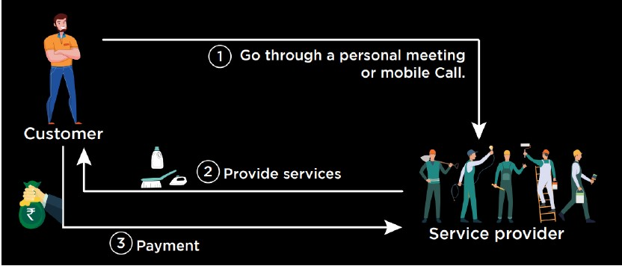

We have observed following limitations in existing system:

* Existing system is offline.
* Difficult to manage records.
* No time limit for service to be provided.
* No guarantied service.
* 24 hours service is not available.
* No security.
* Service record stored in registered.
* After meeting with customer, service provider provides service & customer make payment.
* Difficult for customer to find any service in emergency at any time & place.

### 1.2.2 PROPOSED SYSTEM

A system where all service providers can register them and create their profile to reach a wide range of customers. Customers will directly contact the service providers without any mediator.

So, our proposed system will overcome the limitations of existing system with following features :-

* House hold services easy available.
* To provide house hold services any time.
* Easy online payment.
* Saving of time.
* Make available house hold services through web-application.
* Customer can book service online instead of finding manually.
* Customer can view review of service provider & vice versa.
* Customers will get a chance to choose the service provider.
* Admin manage customer & service provider.

## 1.3 SCOPE OF SYSTEM

* Our system is developed for a particular city. So, we’ll modify our web-app to avail for more cities in future.
* We’ll add map navigation feature in the future. So that service provider can reach to customer easily.

## OBJECTIVES

We often get frustrated while taking the appointment of service provider because there the many problems are occur,  like the service provider is busy art somewhere else or  his not receiving our call or his cost is very high according to problem. So in this project we will remove this headache.

The main aim of the project is to provide an easy to use web-application for services provided for customer.

# 2. PROPOSED SYSTEM REQUIREMENT GATHERING

## 2.1 STAKEHOLDERS OF SYSTEM

**1. ADMIN**

Admin deals with the system operation.

Admin manage the functionalities of system like managing inquires, managing the service provider, managing charges, booking services, service category, customers.

**2. SERVICE PROVIDER**

Service provider is the user of the system which offers there services to the customers.

Service provider can manage their services in the system, view customer details and requests for home services, manage booking services and can view feedback of customers of their services and showcase their service category and experience to the customers.

**3. CUSTOMER**

Customer is the user of the system which uses the functionalities and services provided by the system.

A customer can view service category, service provider details. He/she can request for an appointment and can give there feedback on the Service provider services.

**4. VISITOR**

Visitor is also the user of the system that visits the system without getting registered into the system.

Visitor can view service category, service provider's details and feedback.

## 2.2 REQUIREMENT GATHERING TECHNIQUE USED

**OBSERVATION**

Here, we are gathering the requirements by using Observation techniques in our system.

By observing users, an analyst can identify a process flow, steps, pain points and opportunities for improvement.

In offline system, service provider either got a call from customers through references or through the advertisement. Thus, they got less number of customers. So, an online platform is required where service provider can showcase their skill and experience and get a wider range of customers.

## 2.3 Consolidated List of Requirements

➢ For making it easy to get the home services for customers where they will get different options of service provider.

➢ Service provider will be providing different home services like plumbing, cleaning, painting, packing, etc. Online appointment can be booked using the system.

➢ Customers can get the services they are in need of.

➢ Customers can pay for the services through online payment option.

➢ Customers can also view there appointment status.

➢ They can also provide there valuable feedback for the home services of the service provider they used.

➢ Service provider can view the details of the user.

➢ Service provider can also view the payment status and feedback provided by the customer.

## 2.4 Project Definition

* We are making a web based application of online home services.
* It provides services by providing professional service specialists at your doorstep in one click.
* It is a system where all service providers can register themselves and create their profile to reach a wide range of customers.
* Customers will directly contact the service providers without any mediator.
* Customers will select their service provider they needed.
* Due to which user will be able to save a lot of time.

# 3. SYSTEM MANAGEMENT AND PLANNING

## 3.1 Feasibility study

### 3.1.1 Technical study

* Online home service system is a web based application. The main technologies and tools which are going to be used in online home service are as follows:-
* HTML, CSS
* JavaScript
* PHP
* Apache
* XAMPP
* MySQL
* Diagram tool :- Visual Paradigm
* Each of these technologies is freely available and the skills required are manageable. Time limitation of the product development and the ease of implementing using these technologies are synchronized.
* The project uses the existing technology and works with any windows OS.
* The project does not rely on any of the third party and has a geographical limit.

### 3.1.2 Economical Study

The economic feasibility study evaluates the cost of the software development against income or benefits gets from the developed system.

* The System will follow the freeware standards. No cost will be charged from the potential customers.
* We are going to use open source technologies so no cost will be incurred in the development process.
* As records for booking will be online paper cost will be saved.
* Future Updates will be integrated into the system at no cost.
* So, we can say that our system is economically feasible.

### 3.1.3 Operational Study

Operational feasibility study tests the operational scope of the system to be developed. It checks that if the system can actually be useful when implemented or not.

* Our system is very easy to use without any training.
* Our system is going to be developed by keeping in mind the Service providers and customers.
* The planning includes all stakeholders for the development of the system. So the system will be user friendly for all its stakeholders.
* Thus, our system is operationally feasible and secured.

## 3.2 Hardware/Software Requirement

**• Client Side Requirement:-**

**Hardware Requirement:**

|  |  |
| --- | --- |
| Processor | Minimum Core i5 or Higher |
| RAM | Minimum 2 GB or Higher |
| Hard Disk | Minimum 200 MB or Higher |

**Software Requirement:-**

|  |  |
| --- | --- |
| OS | Minimum windows 8 or Higher |
| Browser | Mozilla v65.02 or Chrome v73.0.3683.86 |

**Server Side Requirement:-**

**Hardware Requirement:-**

|  |  |
| --- | --- |
| Processor | Minimum Core i5 or Higher |
| RAM | Minimum 4 GB or Higher |
| Hard Disk | Minimum 500 MB or Higher |

**Software Requirements :-**

|  |  |
| --- | --- |
| OS | Minimum Windows 7 or Higher |
| Server | Apache Tomcat |
| Database | MySQL |

## 3.3 System Planning

### 3.3.1 Work breakdown Structure

**Online Home Service**

Ch.1: Introduction

Ch.2: Processed System Requirement Gathering

Ch.3: System management and planning

Ch.4: System analysis and planning

1.1 Organization profile

1.2 System Details

1.3 Scope of System

1.4 Objectives

2.1 Stakeholder of system

2.2 Requirement gathering technique used

2.3 consolidated list of requirement

2.4 Project definition

3.1 feasibility study

3.2 Hardware Software requirements

3.3 System planning

3.4 Process model

4.1 UML (unified modelling language)

4.2 System flow diagram

4.3 Data dictionary

4.4 User interface

4.5 System navigation

### 3.3.2 Gantt Chart



## 3.4 Process Model

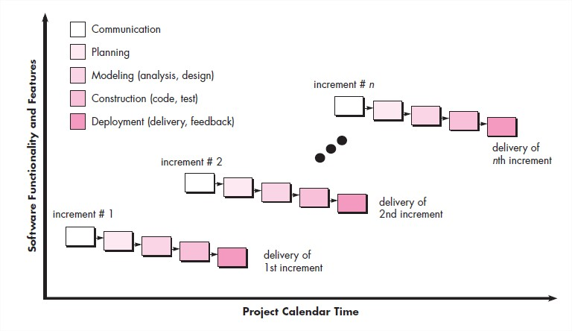

* Each iteration passes through the requirements, design, coding and testing phases. And each subsequent release of the system adds function to the previous release until all designed functionality has been implemented.
* This model is more flexible – less costly to change scope and requirements.
* It is easier to test and debug during a smaller iteration.
* In this model customer can respond to each built.
* Lowers initial delivery cost.
* This process model helps to manage technical risks.
* Initial product delivery is faster.

# 

# Ch 4 System Analysis and planning

## 4.1UML (Unified Modeling Language)

4.1.1 Use Case Diagrams

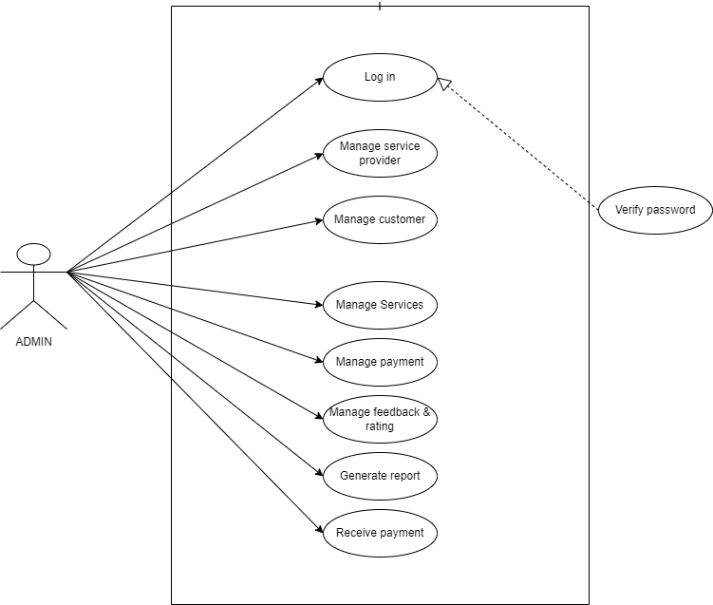

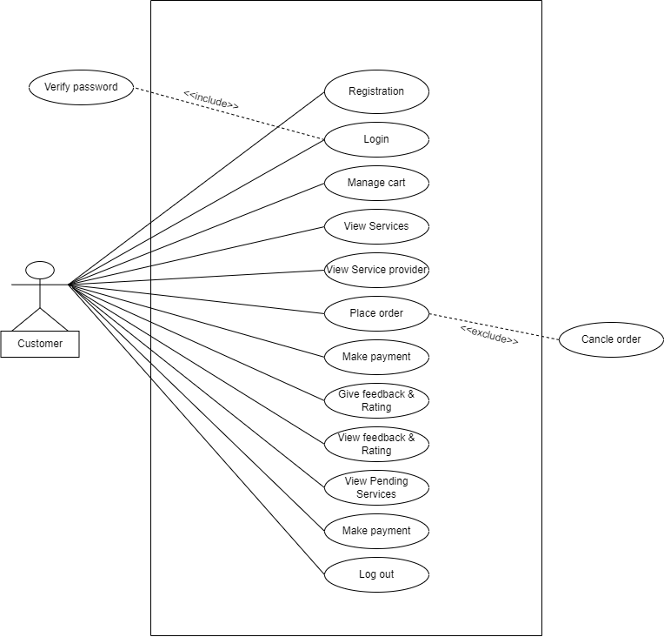

### 4.1.2 Activity Diagram

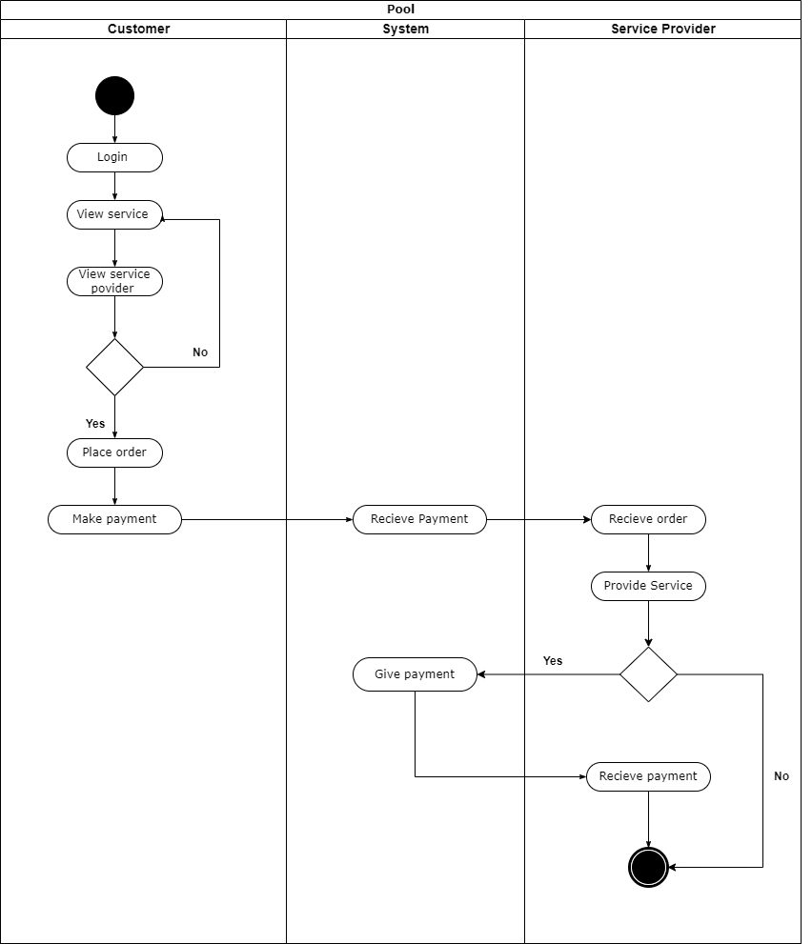

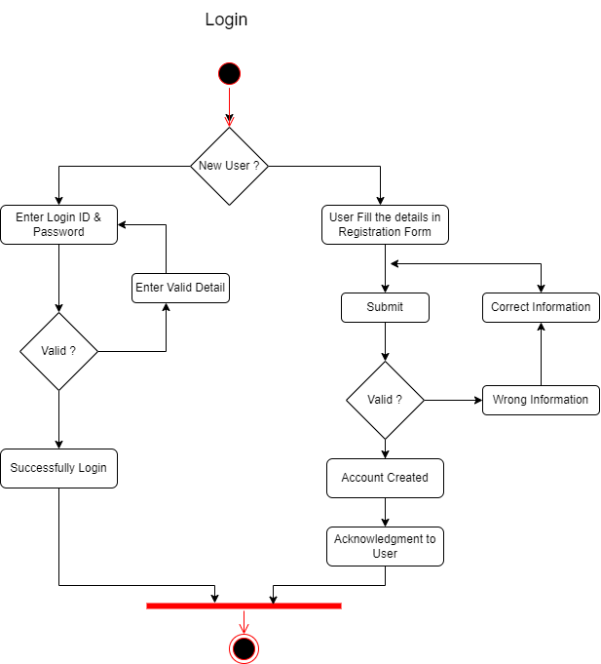

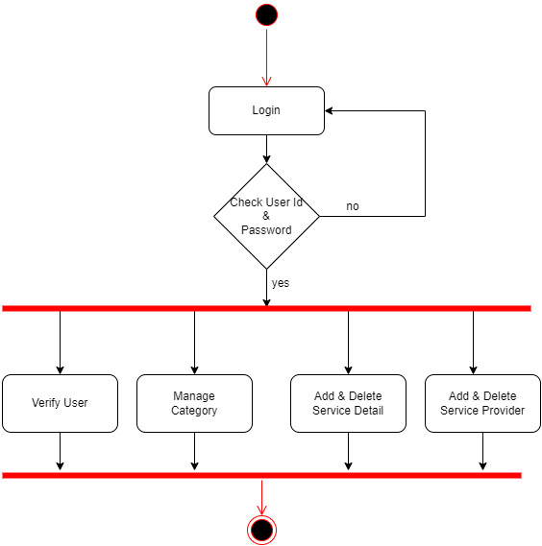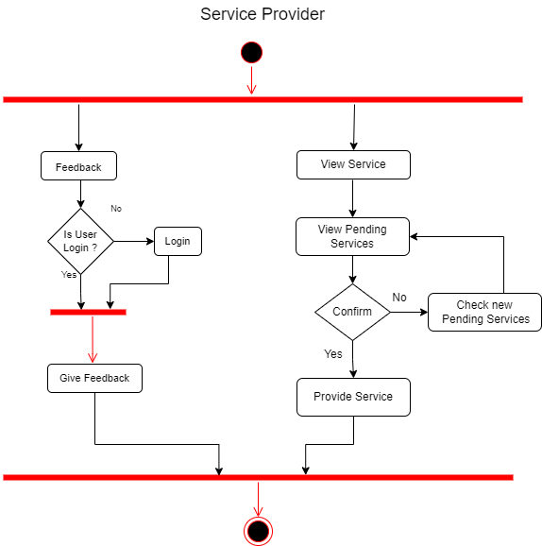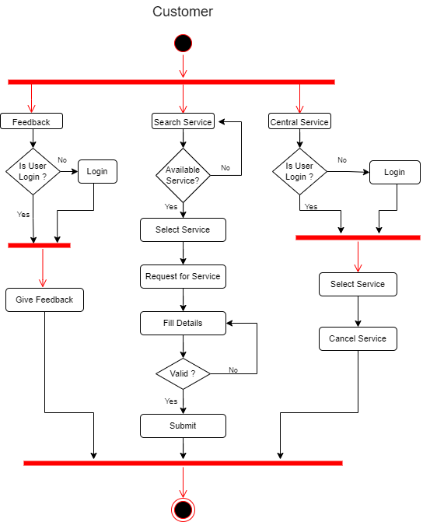

4.1.3 Sequence Diagram

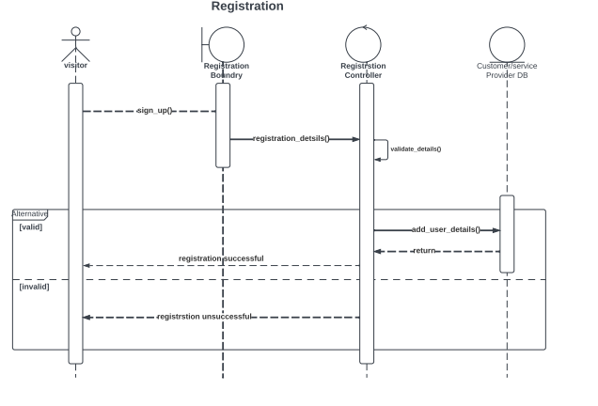

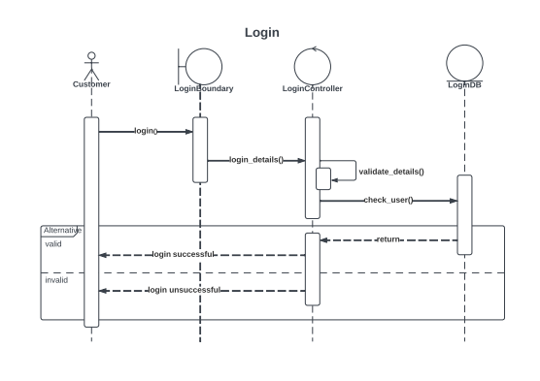

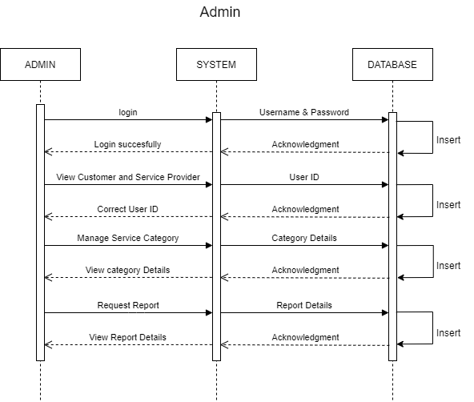

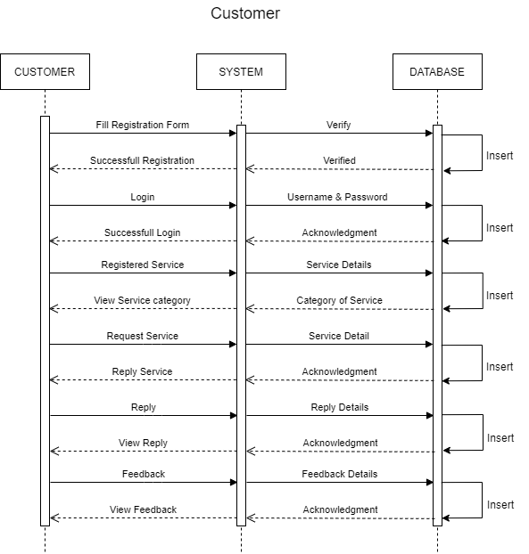

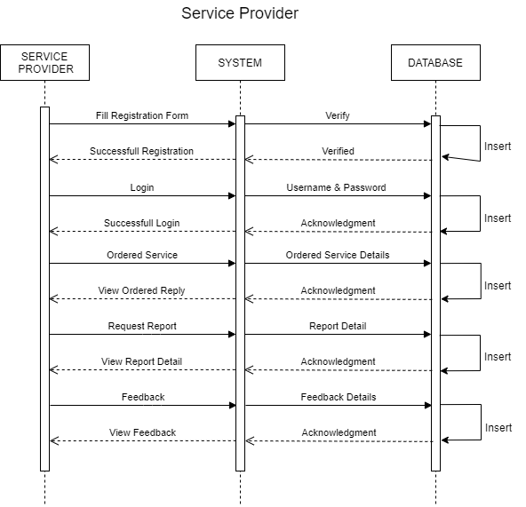

## 4.2 System flow Diagram

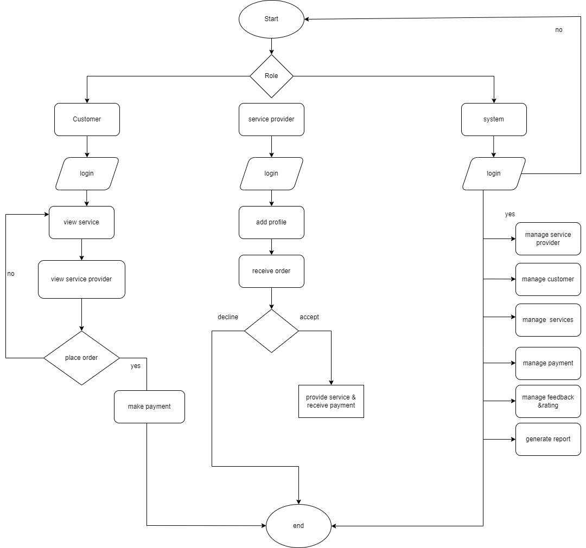

## 4.3 DATA DICTIONARY

**Role**

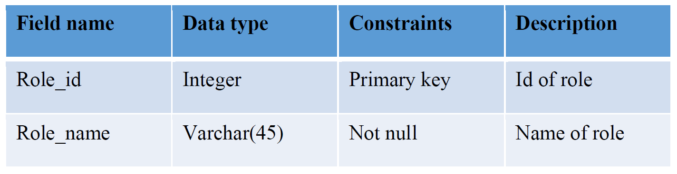

**Login**

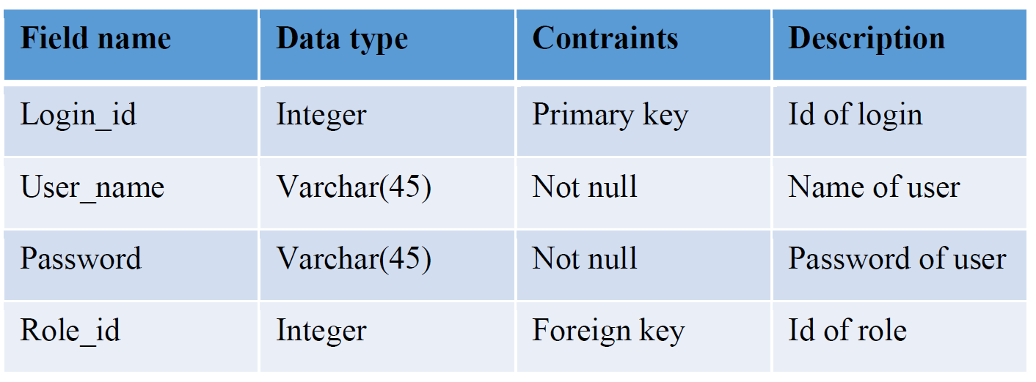

**State**

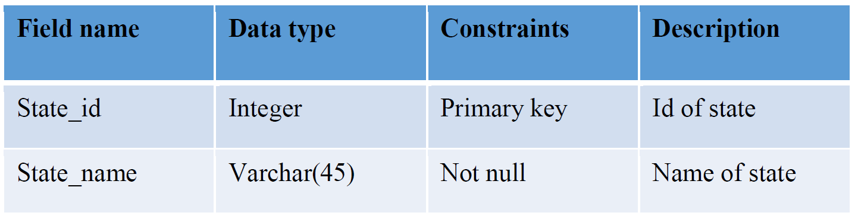

**City**

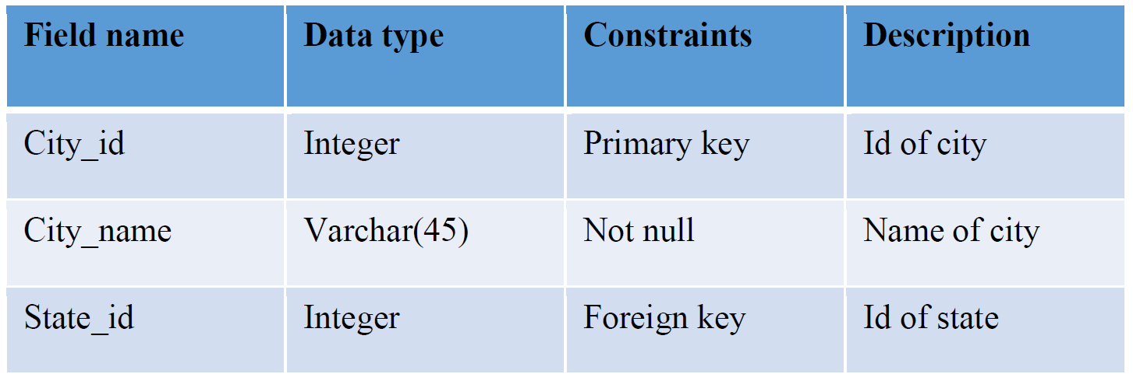

**Area**

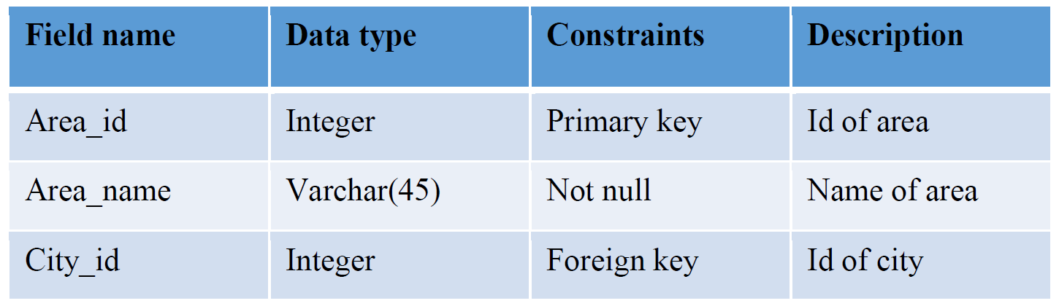

**Customer**

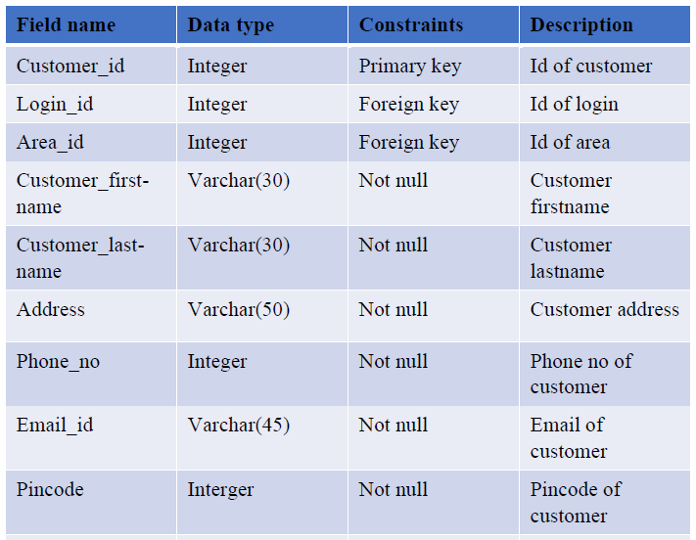

**Service_category**

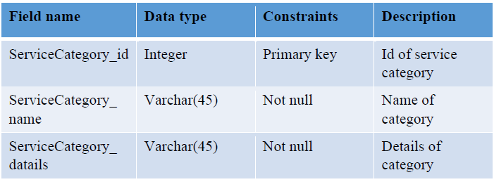

**Service­_provider**

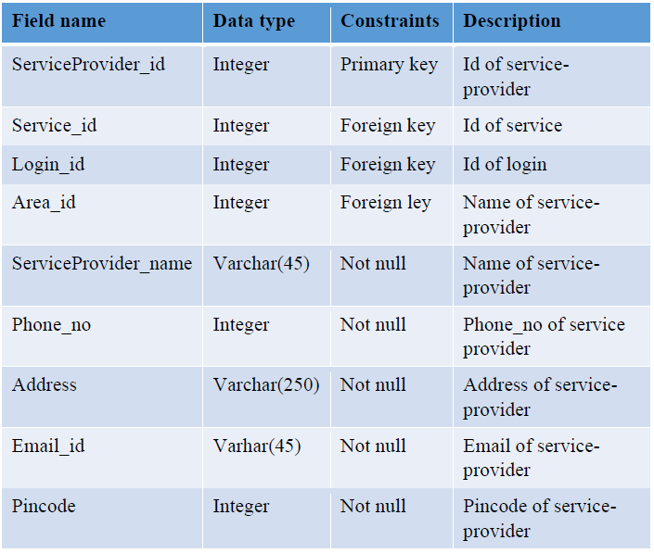

**Refund**

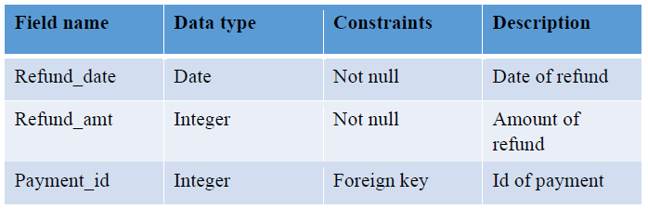

**Service**

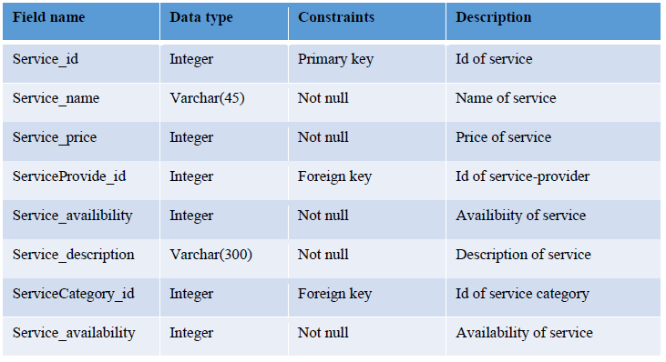

**Order**

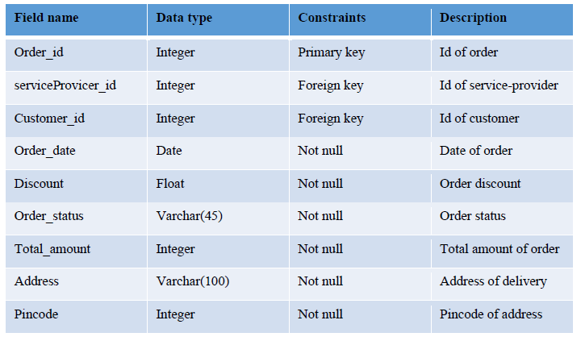

**Order_details**

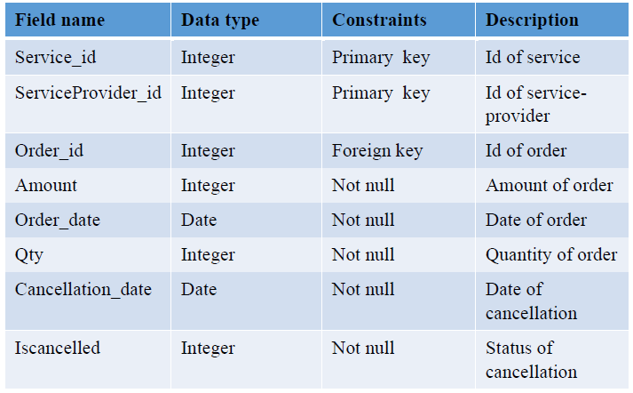

**Service_provider_has_service**

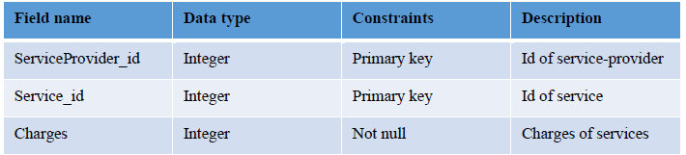

**Customer_feedback**

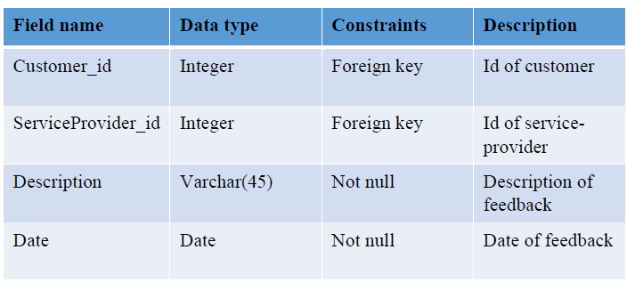

**Service_provider_feedback**

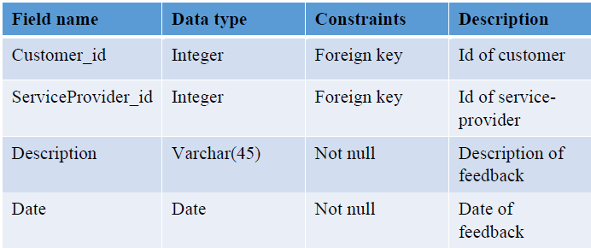

**Service_provider_rating**

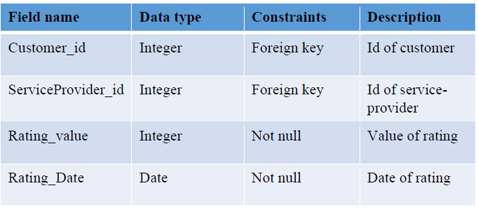

**Customer_rating**

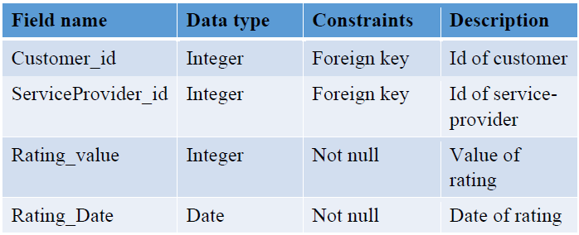

**Manage_cart**

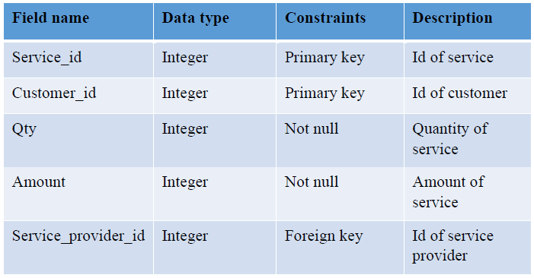

**Payment**

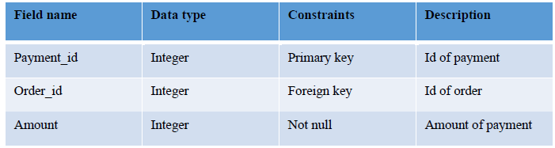

## 4.4 User Interface

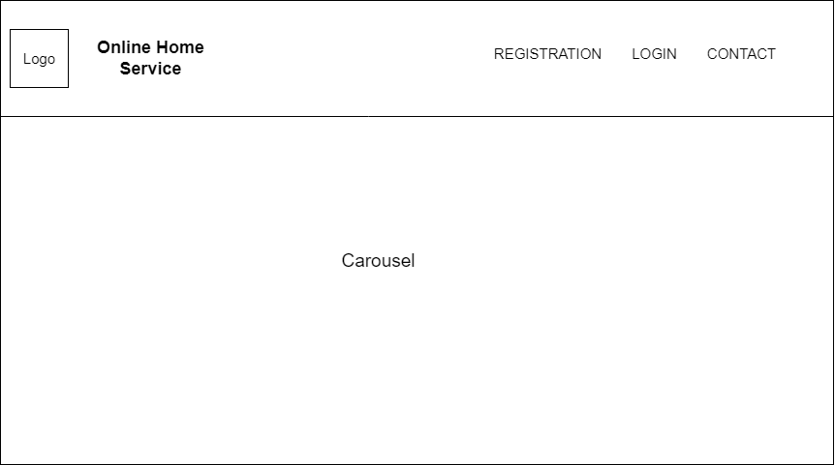

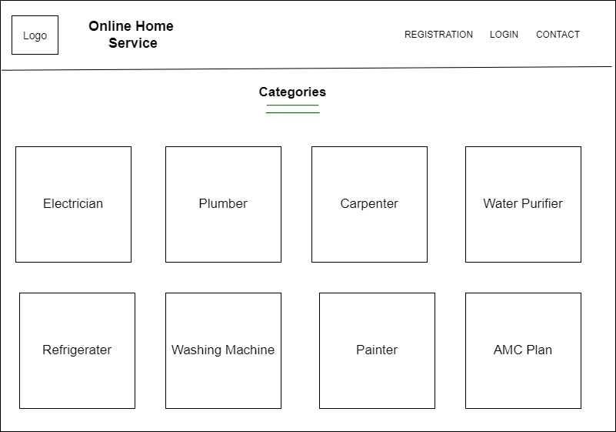

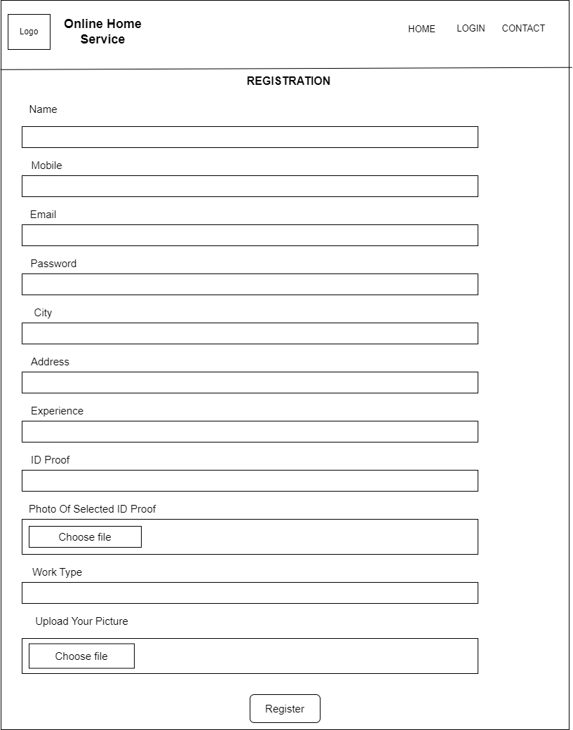

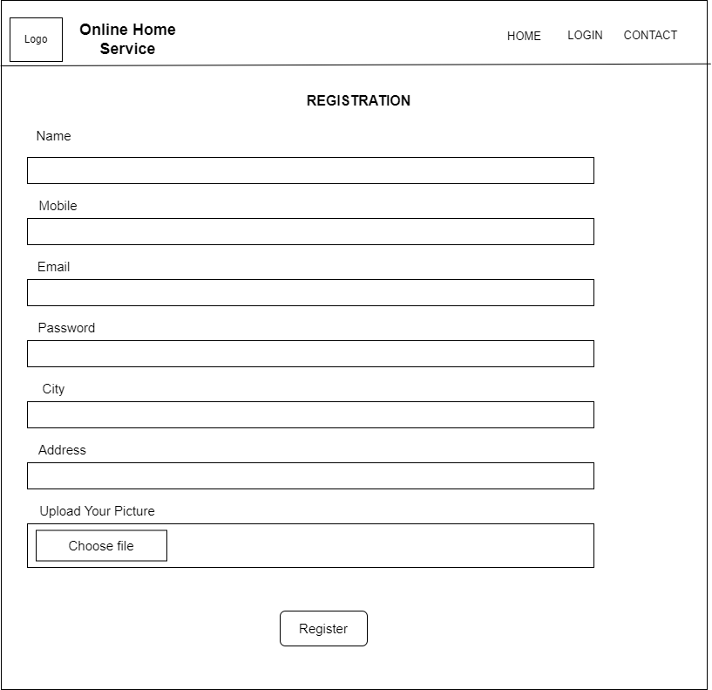

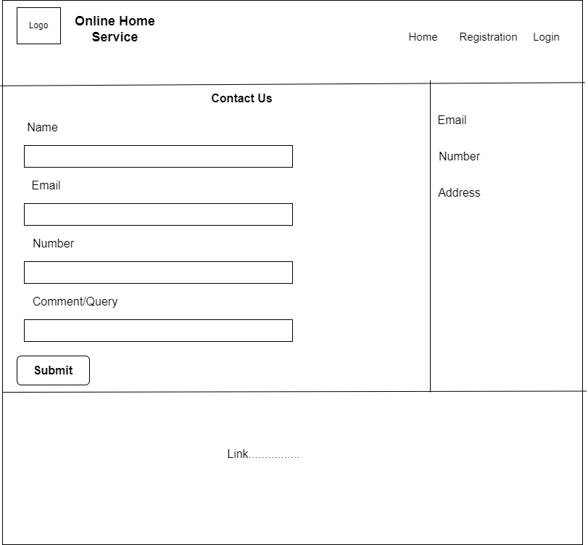

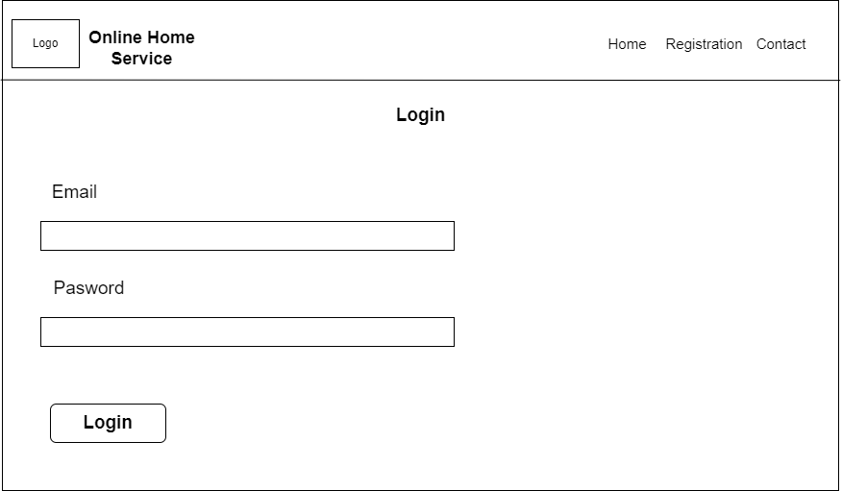

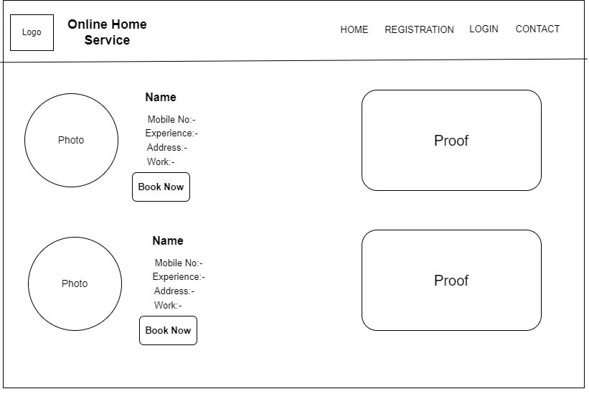

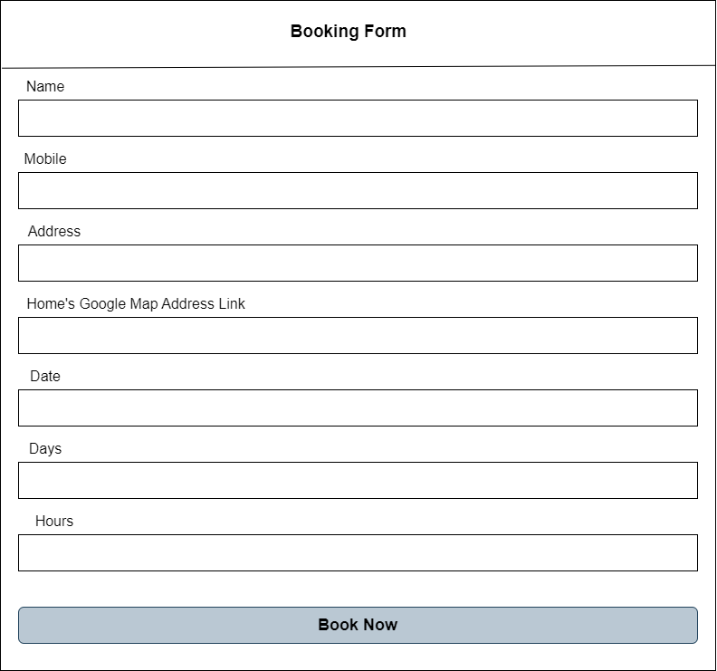

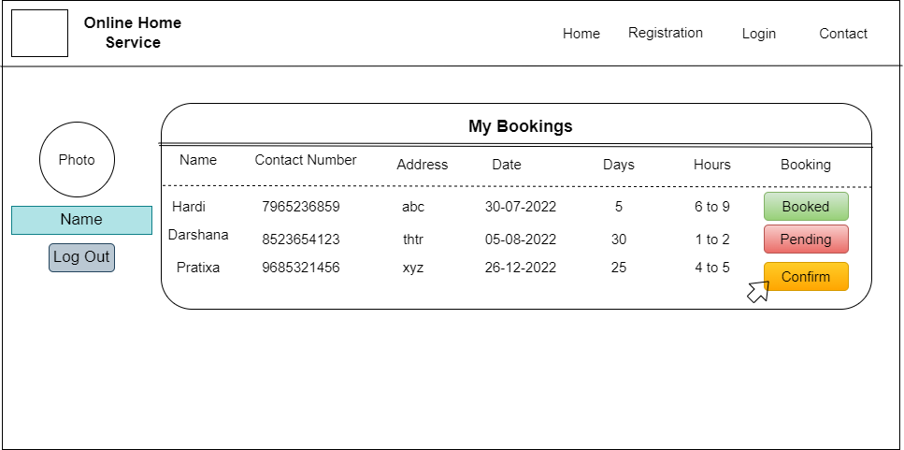

## 4.5 System Navigation

